Register / Login page

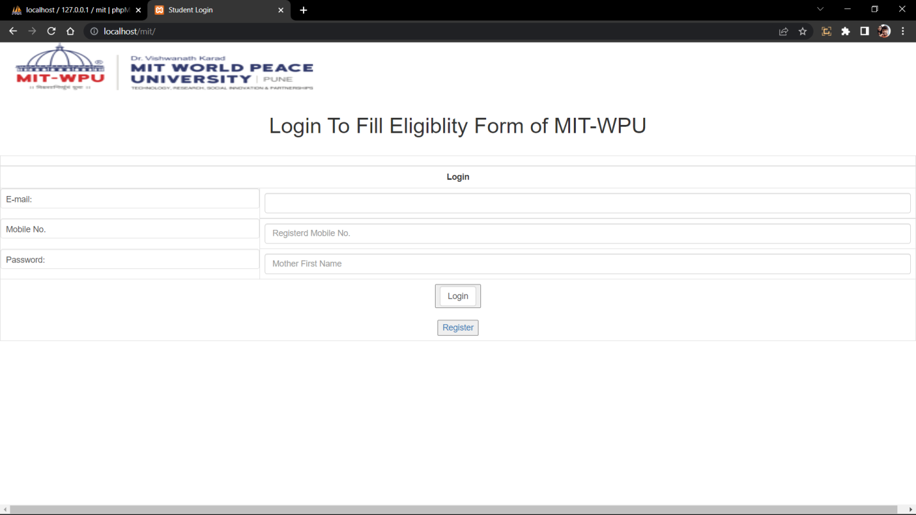

Register Page means that if the user had not have login details then he has to register this first.

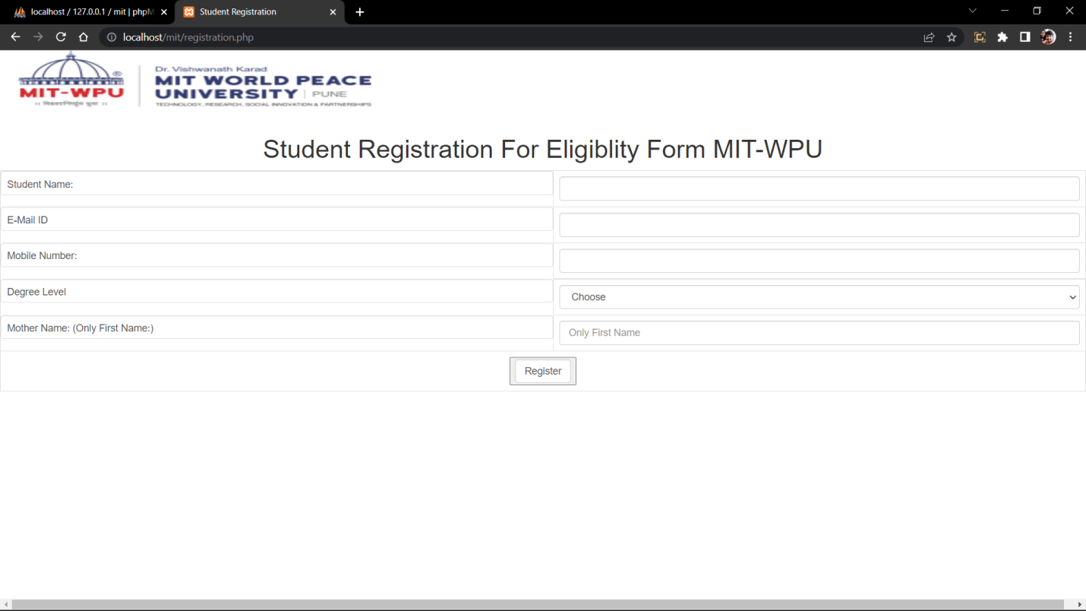

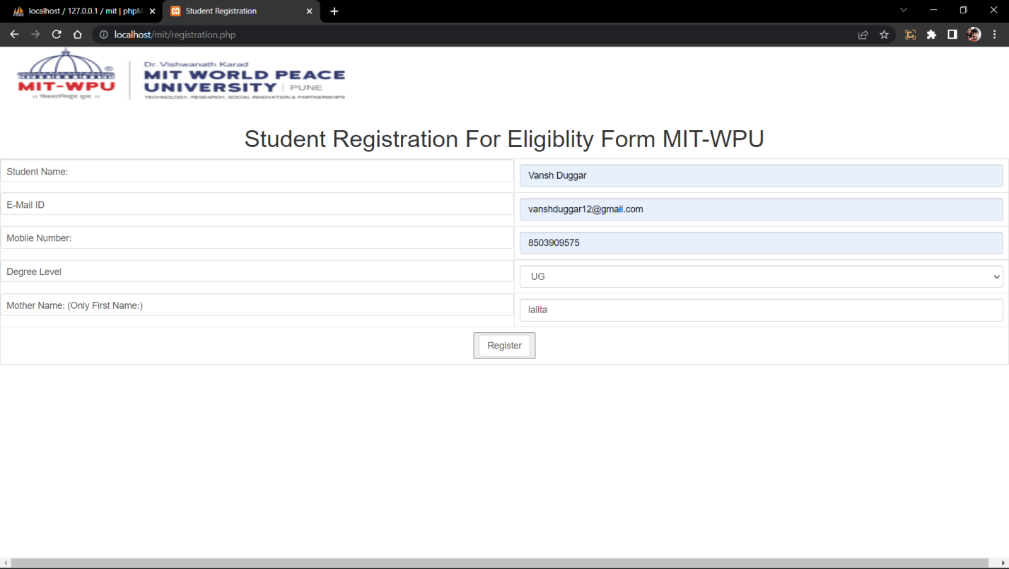here the student will register by giving information.

Now the student have to login with he/she had given details in registration form.

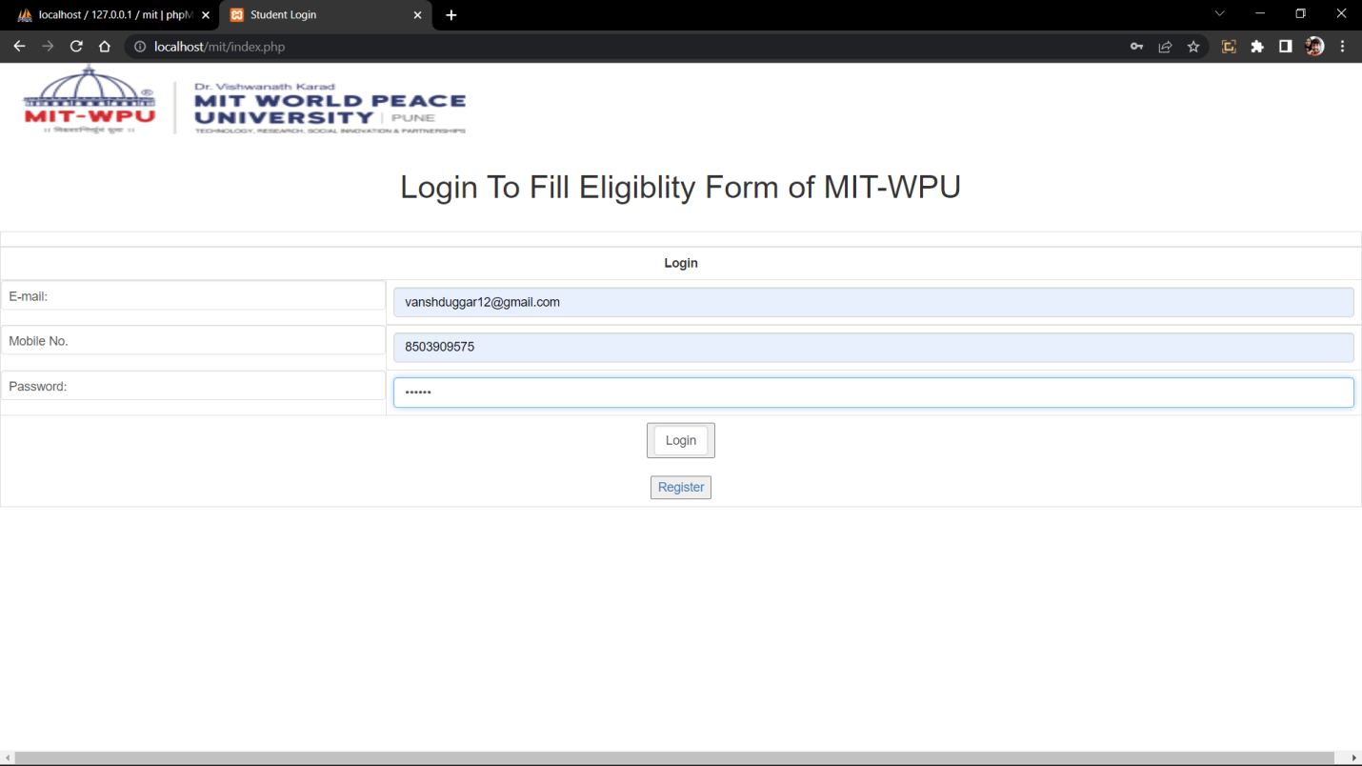

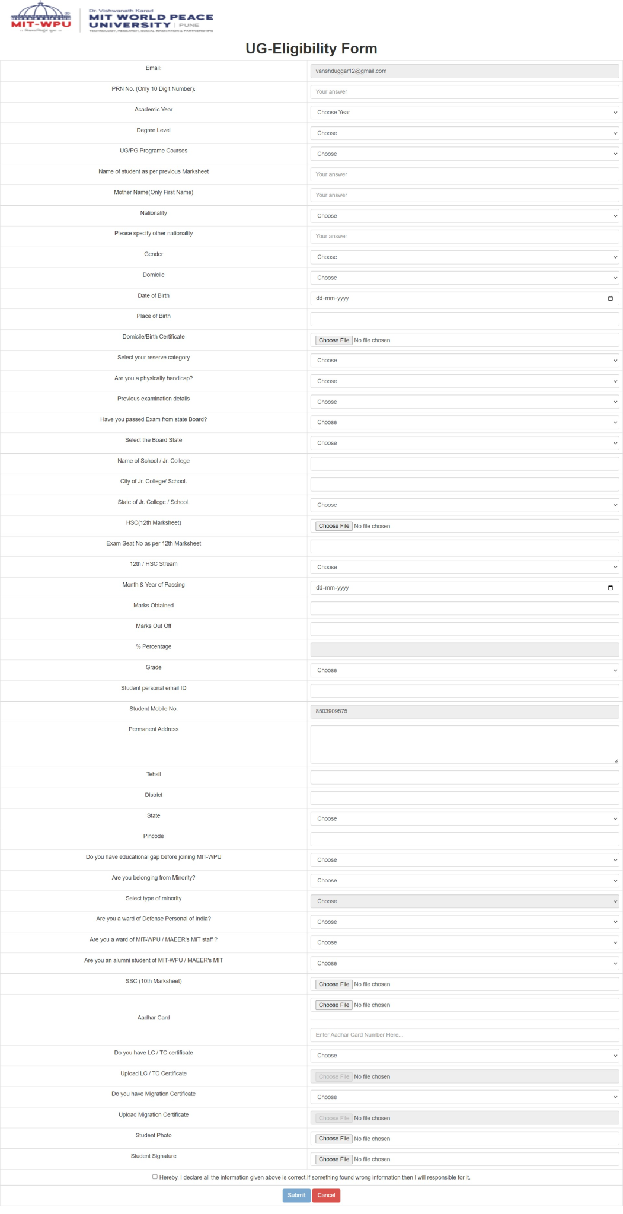Now here if the student has selected the UG course so that he have to fill his UG Eligibity form.

After filing the information student have to submit this